**NAME: TAHA IMTIAZ**

**ROLL NUMBER: 31534**

**PYTHON ASSIGNMENT**

**QUESTION 1:** Write a program to solve a classic ancient Chinese puzzle.  
We count 35 heads and 94 legs among the chickens and rabbits in a  
farm. How many rabbits and how many chickens do we have?

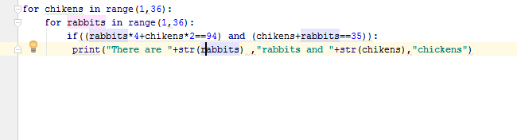

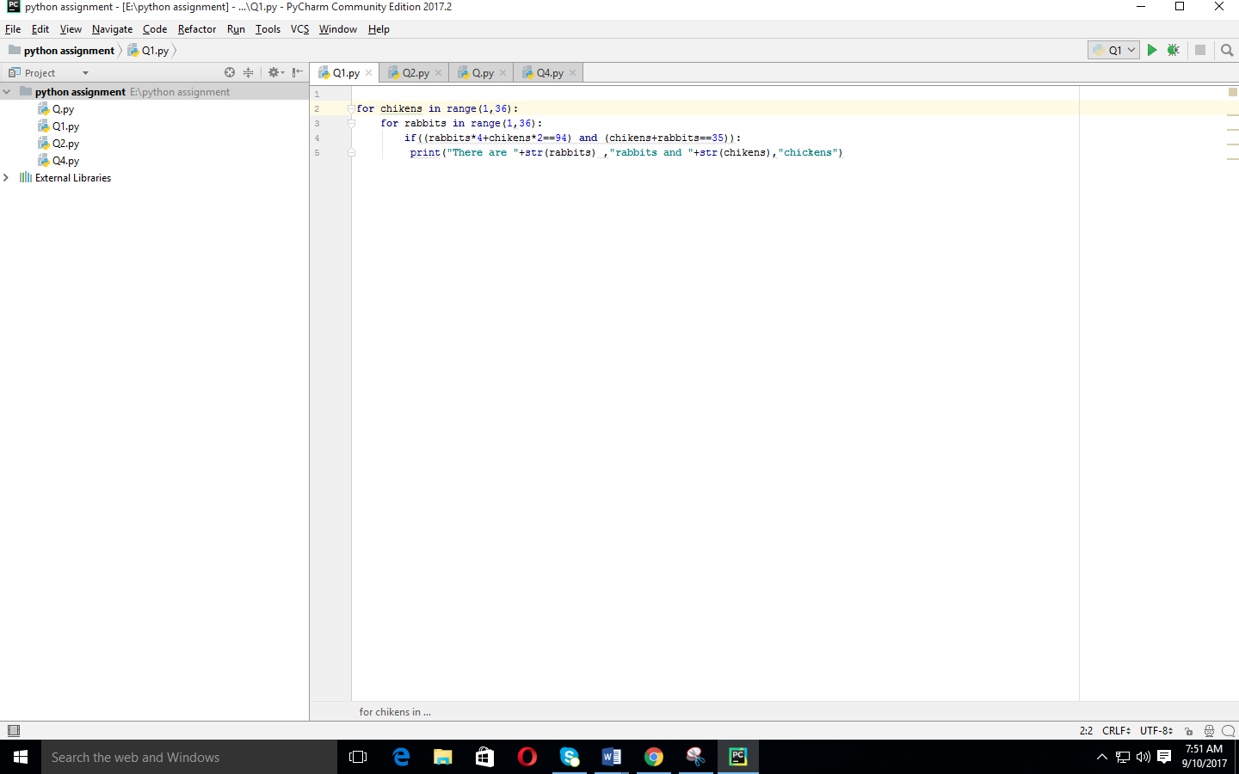

**QUESTION 2:**

Please write a program which accepts a string from console and print the characters that have even indexes. Example: If the following string is given as input to the program: H1e2l3l4o5w6o7r8l9d Then, the output of the program should be: Helloworld Hints: Use list [::2] to iterate a list by step 2.

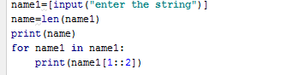

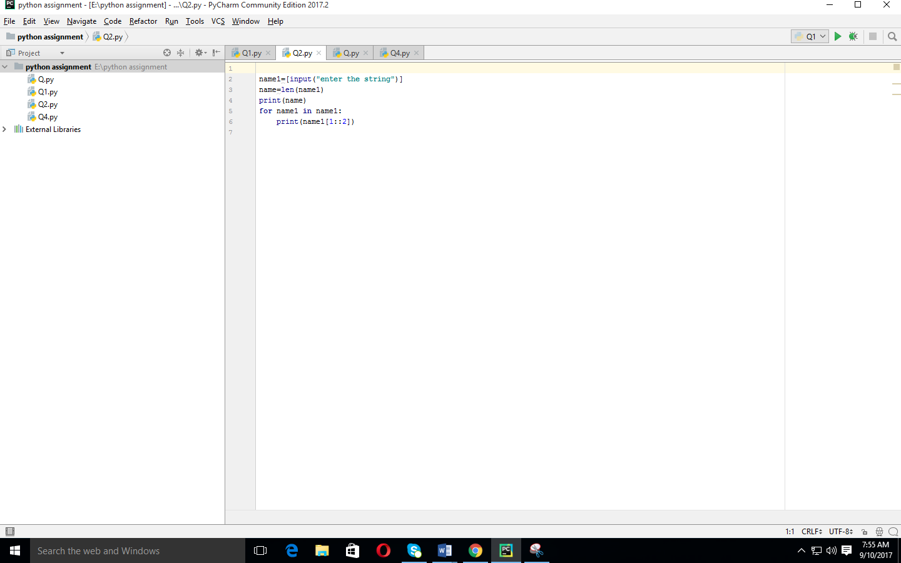

**QUESTION 3:**

Please write a program which accepts a string from console and print it in reverse order. Example: If the following string is given as input to the program: rise to vote sir Then, the output of the program should be: ris etov ot esir Hints: Use list[::-1] to iterate a list in a reverse order.

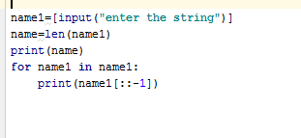

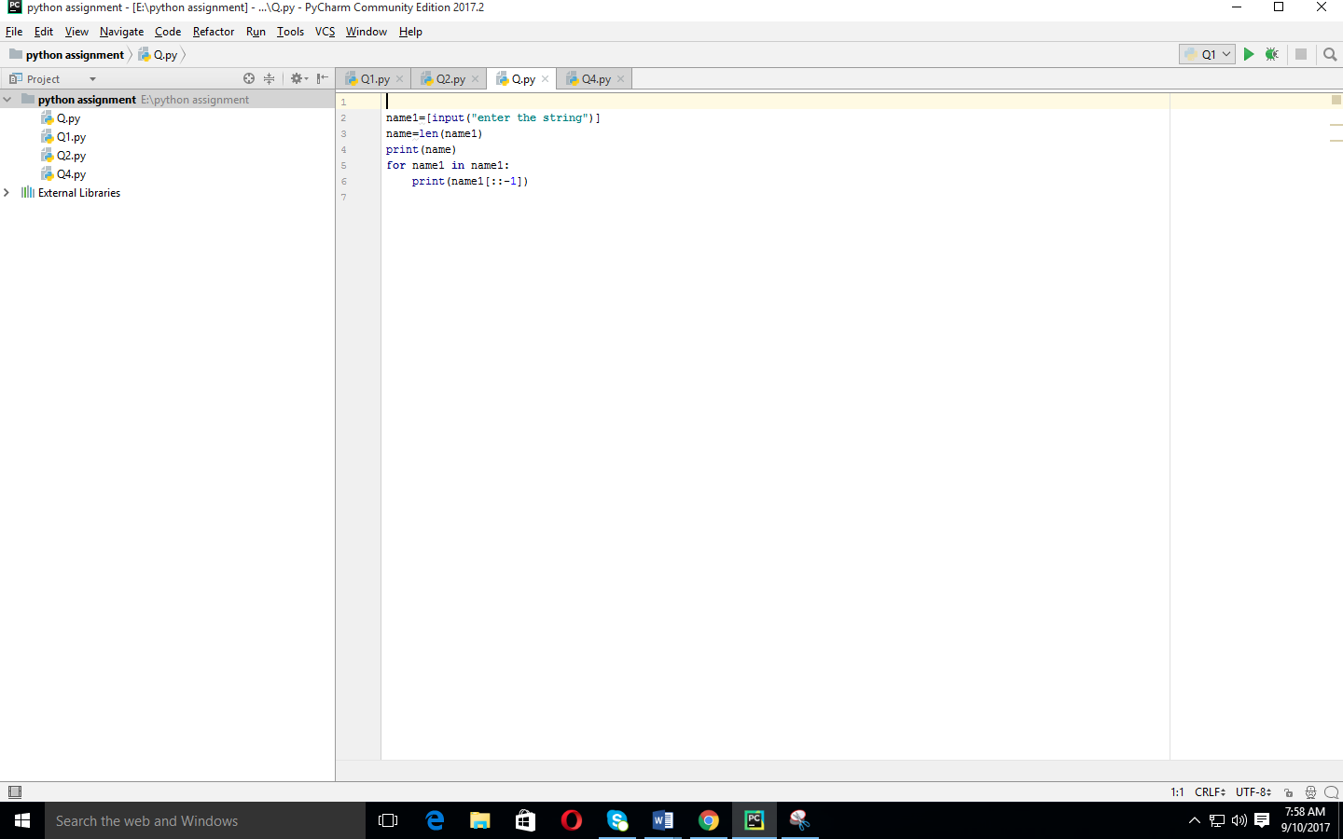

**QUESTION 4:**

Please write a program which count and print the numbers of each character in a string input by console. Example: If the following string is given as input to the program: abcdefgabc Then, the output of the program should be: a,2 c,2 b,2 e,1 d,1 g,1 f,1 Hints: Use dict to store key/value pairs. Use dict.get() method to lookup a key with default value

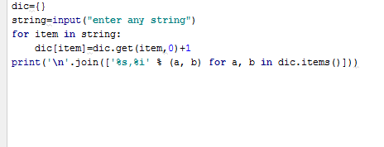

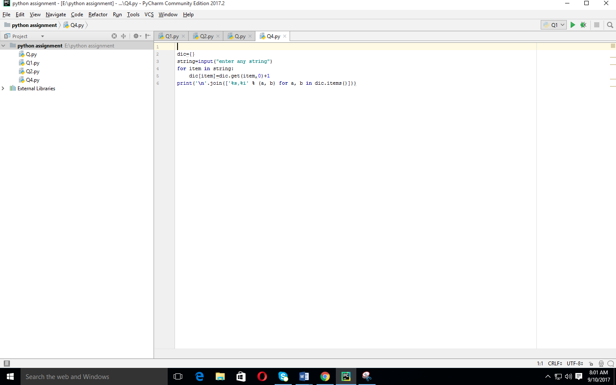

**QUESTION 5:**

Define a class named Shape and its subclass Square. The Square class has an init function which takes a length as argument. Both classes have a area function which can print the area of the shape where Shape's area is 0 by default. Hints: To override a method in super class, we can define a method with the same name in the super class.

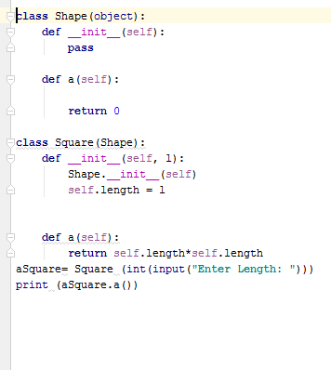

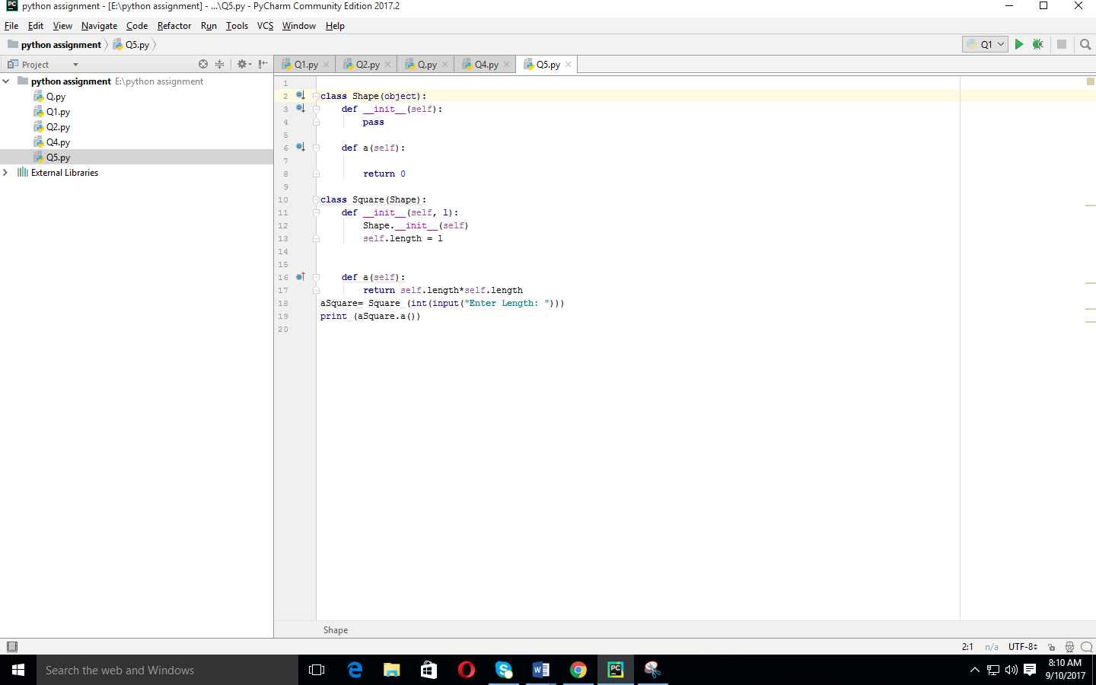

**QUESTION 6:**

Write a function to compute 5/0 and use try/except to catch the exceptions. Hints: Use try/except to catch exceptions.

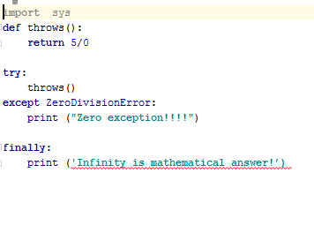

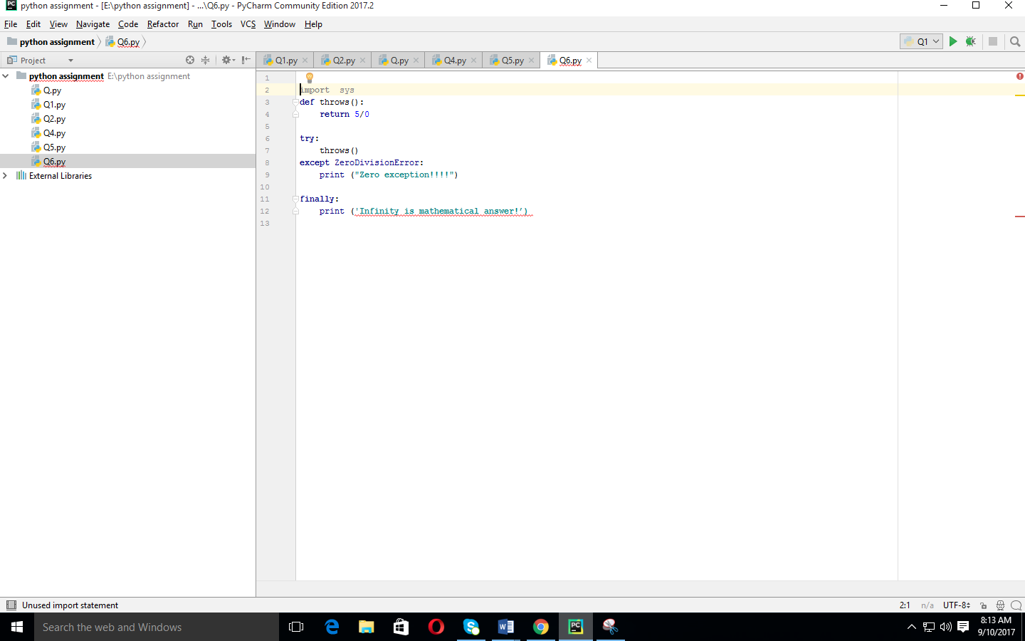

**QUESTION 7:**

Assuming that we have some email addresses in the "username@companyname.com" format, please write program to print the user name of a given email address. Both user names and company names are composed of letters only. Example: If the following email address is given as input to the program: john@google.com Then, the output of the program should be: john In case of input data being supplied to the question, it should be assumed to be a console input. Hints: Use \w to match letters.

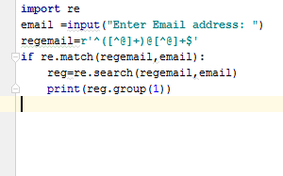

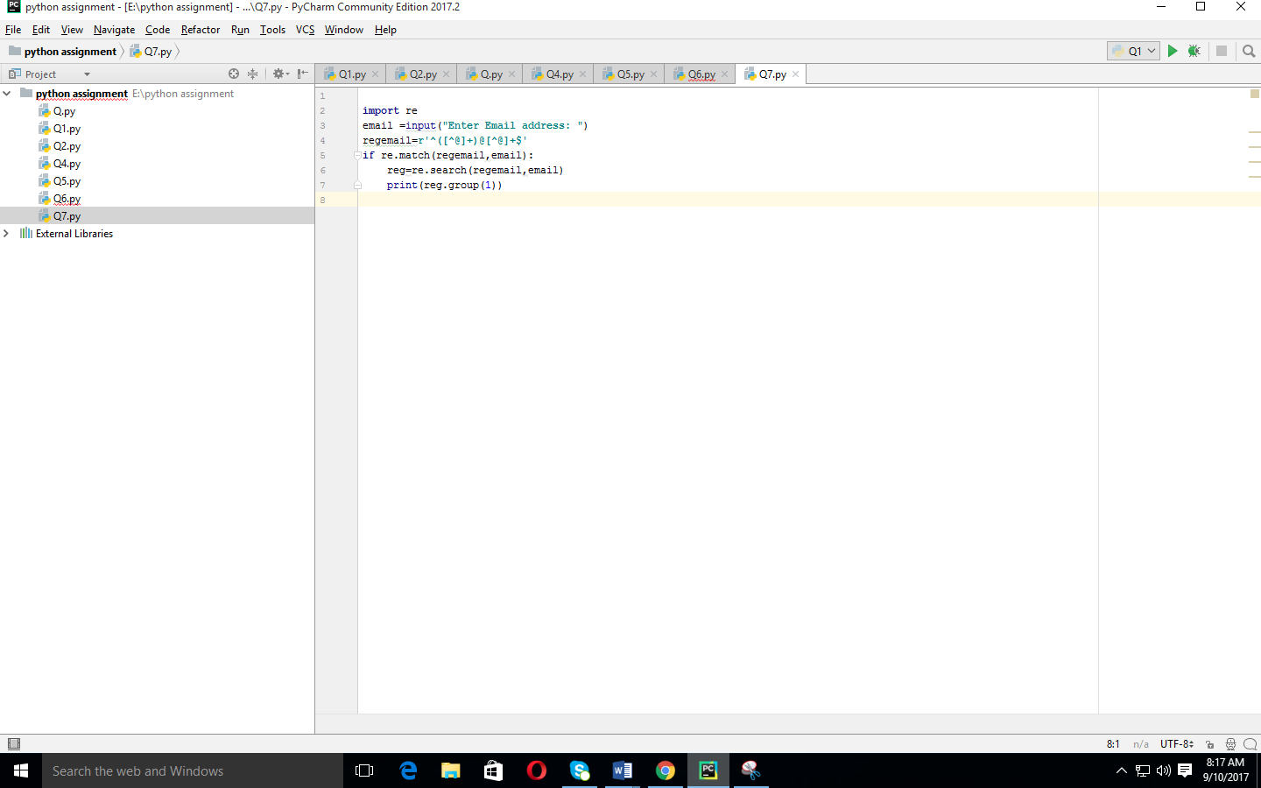

**QUESTION 9:**

Write a program to compute 1/2+2/3+3/4+...+n/n+1 with a given n input by console (n>0). Example: If the following n is given as input to the program: 5 then, the output of the program should be: 3.55 In case of input data being supplied to the question, it should be assumed to be a console input. Hints: Use float() to convert an integer to a float

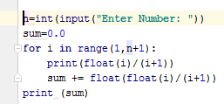

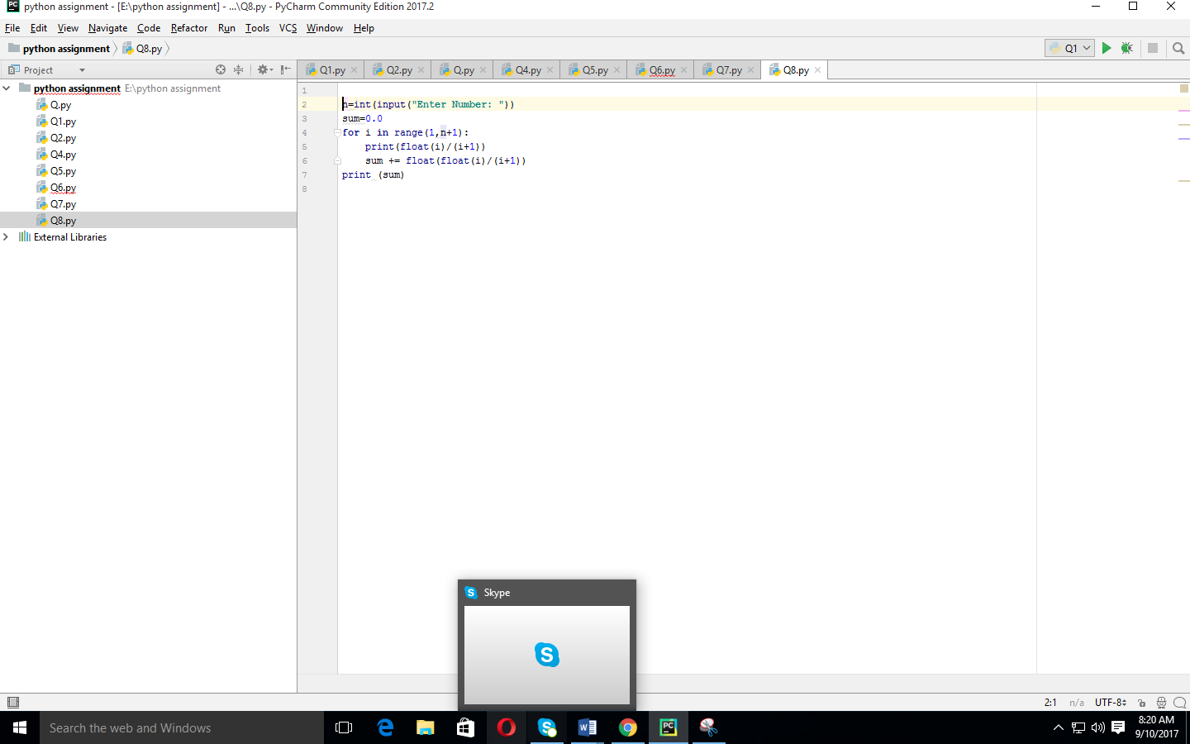

**QUESTION 10:**

Write a program to compute: f(n)=f(n-1)+100 when n>0 and f(0)=1 with a given n input by console (n>0). Example: If the following n is given as input to the program: 5 Then, the output of the program should be: 500 In case of input data being supplied to the question, it should be assumed to be a console input. Hints: We can define recursive function in Python.

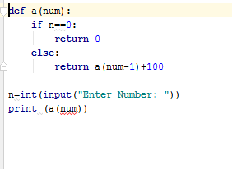

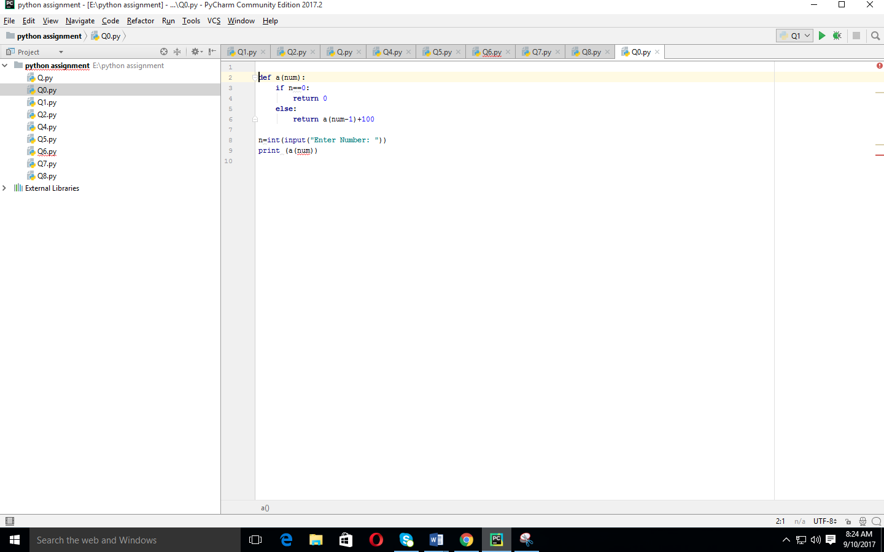

**QUESTION 11:**

A website requires the users to input username and password to register. Write a program to check the validity of password input by users. Following are the criteria for checking the password: 1. At least 1 letter between [a-z] 2. At least 1 number between [0-9] 1. At least 1 letter between [A-Z] 3. At least 1 character from [$#@] 4. Minimum length of transaction password: 6 5. Maximum length of transaction password: 12 your program should accept a sequence of comma separated passwords and will check them according to the above criteria. Passwords that match the criteria are to be printed, each separated by a comma. Example if the following passwords are given as input to the program: ABd1234@1,a F1#,2w3E*,2We3345 Then, the output of the program should be: ABd1234@1 Hints: In case of input data being supplied to the question, it should be assumed to be a console input.

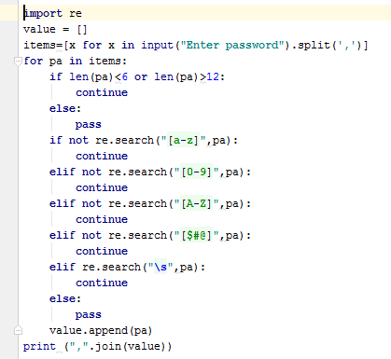

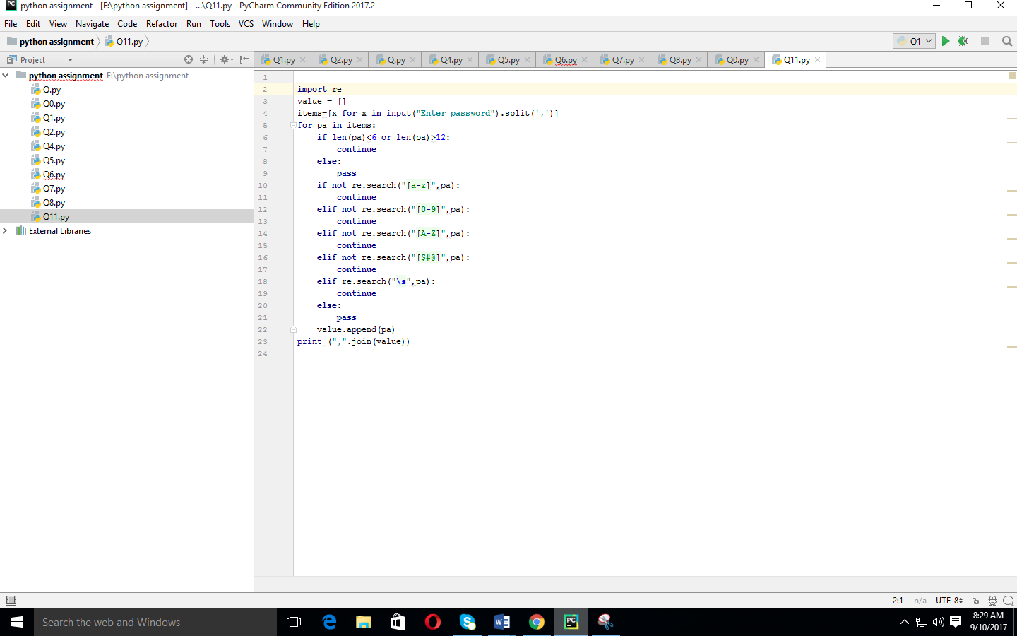

**QUESTION 12:**

You are required to write a program to sort the (name, age, height) tuples by ascending order where name is string, age and height are numbers. The tuples are input by console. The sort criteria is: 1: Sort based on name; 2: Then sort based on age; 3: Then sort by score. The priority is that name > age > score. If the following tuples are given as input to the program: Tom,19,80 John,20,90

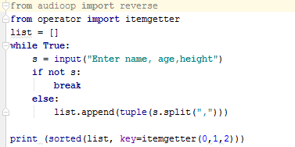

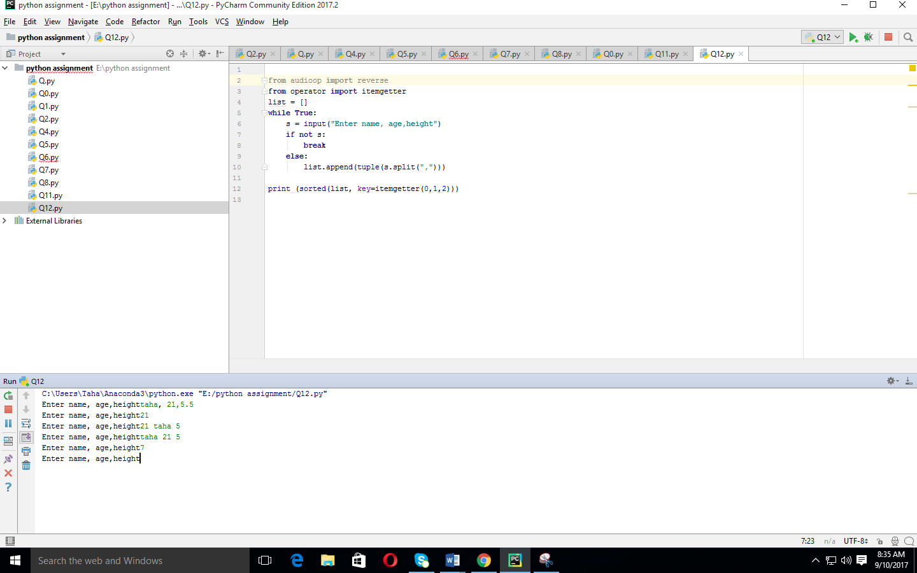

**QUESTION 13:**

Define a class with a generator which can iterate the numbers, which are divisible by 7, between a given range 0 and n. Hints: Consider use yield

